
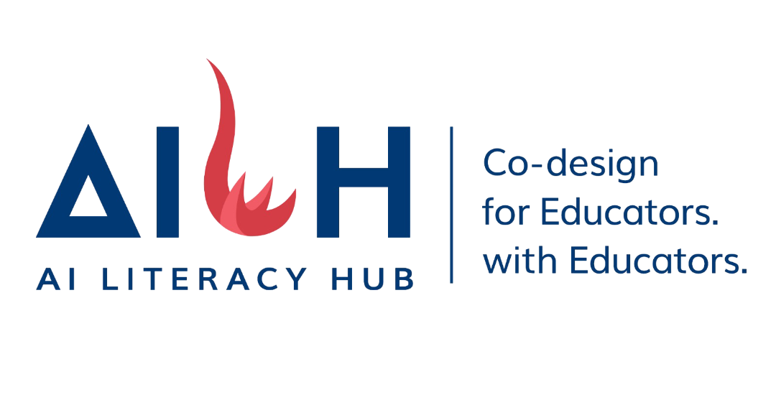
AI for Science - Part B

School Full Name | Fanling Kau Yan College
PIC Full Name | Mr. Tse Ho Wing
PIC Email Address | howing@fkyc.edu.hk
PIC Contact No. | 62130280

EDB Requirements – Complete before 31/8/2027
1. Two lesson plans - teaching plan, teaching resources
2. One opening session – deck of the lesson, student questionnaire and analysis
3. One Sharing session – deck of the sharing session

Part B – Agenda – Supporting areas

Items | Topic / focus
1 | Conduct in-depth demonstration of Goodclass.ai
2 | Discuss sample references of AI-assisted teaching in AI for Science (S1-3) curriculum units (1-13 units)
3 | Assist schools in Lesson Design & Evaluation Tool form submission (PACI form)
4 | Assist schools in developing teaching examples or resources with the application of AI in Science (lesson plan)
5 | Arrange open class or classroom demonstration with the use of AI-assisted teaching in Science
6 | Arrange school experience sharing session

Question List

Required output | Topic / focus
Lesson Plan 1 | Science topic: S1 Integrated Science – Unit 1: Introducing Science (1.2A Basic steps of a scientific investigation & 1.2D Fair test: Dissolving salt in water of different temperatures, 25°C vs. 80°C)  • AI Platform: https://tsehowingpeter-sys.github.io/rate-of-dissolving-fair-test/  • Focus & Workflow: Students use the custom web platform and AI buddy "Agent Water (水精靈)" across 3 SRL stages: (1) Planning – identifying the problem ("W" rule), hypothesis, and drag-and-drop fair test variables; (2) Data Entry – 4-student groups split into Sub-groups A & B to record 25°C vs. 80°C dissolving times with live 8-group class averaging; (3) AI Dialogue & Reflection – guided inquiry on how temperature affects dissolving rate (particle kinetic energy) and "I used to think... Now I think..." metacognitive reflection.
Lesson Plan 2 | Science topic: S1 Integrated Science – Unit 2: Water (2.3B / Exp 2.5 Factors affecting the rate of dissolving: Investigating how volume of water [50 cm³–200 cm³] affects dissolving rate & error analysis)  • AI Platform: https://tsehowingpeter-sys.github.io/rate-of-dissolving-open-class/  • Focus & Workflow: Built on the school-based SRL TAB framework, students conduct fair tests across 4 water volumes (50 cm³, 100 cm³, 150 cm³, 200 cm³), synchronize data across 8 groups in real time, and engage in multi-round Socratic dialogue with "Agent Water (水精靈)" to evaluate data reliability, identify 3 core error sources (Random Error, Manual Stirring Lag, Subjective Endpoint Judgment), and justify matching experimental improvements (e.g., magnetic stirrer, light/turbidity sensor) before group synthesis on iBoard.
One open class / demonstration | • Date & Time: 4 November 2026 (Wednesday), 10:45 a.m. – 11:35 a.m. (Period 3, Class 1CL)  • Selected Plan: Lesson Plan 2  • Lesson Topic: S1 Integrated Science (Unit 2: Water) – 2.3B / Exp 2.5 Factors Affecting the Rate of Dissolving
One experience sharing session | • Date: 4 November 2026 (Wednesday) (held on the same day as the Open Class event)  • Time: 09:50 a.m. – 12:20 p.m. (Pre-lesson Talk & School SRL + AI Experience Sharing: 10:05 a.m. – 10:40 a.m.; Post-lesson Professional Conference & Discussion: 11:40 a.m. – 12:20 p.m.)
2026 Award Scheme (yes/no) | Yes. Award: Silver Award (achieved in the 2026 Award Scheme)
2027 Award Scheme (yes/no) | Yes. Topic: AI-Empowered Scientific Investigation on Factors Affecting the Rate of Dissolving (with Socratic AI Buddy "Agent Water")
Part A participation | Part B only
Current use of AI | Yes, actively applied in class.  • School-based Framework (SRL TAB): Since 2023, the school has established an "AI + Subject" Professional Learning Community (PLC) and integrated AI into its Self-Regulated Learning framework (SRL TAB: Talk Moves, Thinking Routines, AI, Bansho). Science and other subject teachers also received the Outstanding Performance Award in the HKAHSS Self-Regulated Learning Teacher Award Scheme (2025/2026).  • Custom AI Learning Buddies & Diagnostic Platforms: Developed custom web-based interactive inquiry platforms featuring the Socratic AI buddy "Agent Water (水精靈)" and a real-time Teacher Command Center (cross-device MQTT synchronization across 8 student groups).  • Pedagogical Role of AI: Positioned AI as a "More Knowledgeable Other (MKO)" and thinking lever rather than a direct answer provider—scaffolding fair-test variable control, real-time multi-group data comparison, Socratic error analysis, and personalized Key Learning Points summaries.

Part B - Zoom /On-site support

Zoom Support | On-site Support
Preparations – AI for Science materials, teaching resources | AI tool guidance - Hands-on tool practice with teachers
Document review – check teaching resources, worksheets, etc… | Review lesson plans, teaching resources, PACI form and suggest improvements
Open-class or sharing-session preparations - review presentation slides, student questionnaire, technical readiness | On-site open-class or sharing-session support

